Mirrors – Autofold and Reverse Tilt Control Function – CGEA1.3

Functional Description

This STSS handles the setting of auto folding and reverse tilting of the rearview mirrors feature available to the customers thru the Personalization menu.

The Instrument Cluster uses the Personalization signals from the DDM module for the Message Center function to enable or disable the rearview mirror control features in the DDM module.

The customer uses the message center switches and display to enable and/or change the rearview mirror control settings in the vehicle.

Starting in MY2019 with U625/U611 the Settings are migrating from the cluster to Center stack. This STSS supports displaying settings in the cluster or configuring the cluster settings off if they are displayed in the Center stack.

Interfaces

Interface Context Diagram (I/O Block Diagram)
Figure 1 Mirrors – Autofold and Reverse Tilt Function Context Diagram
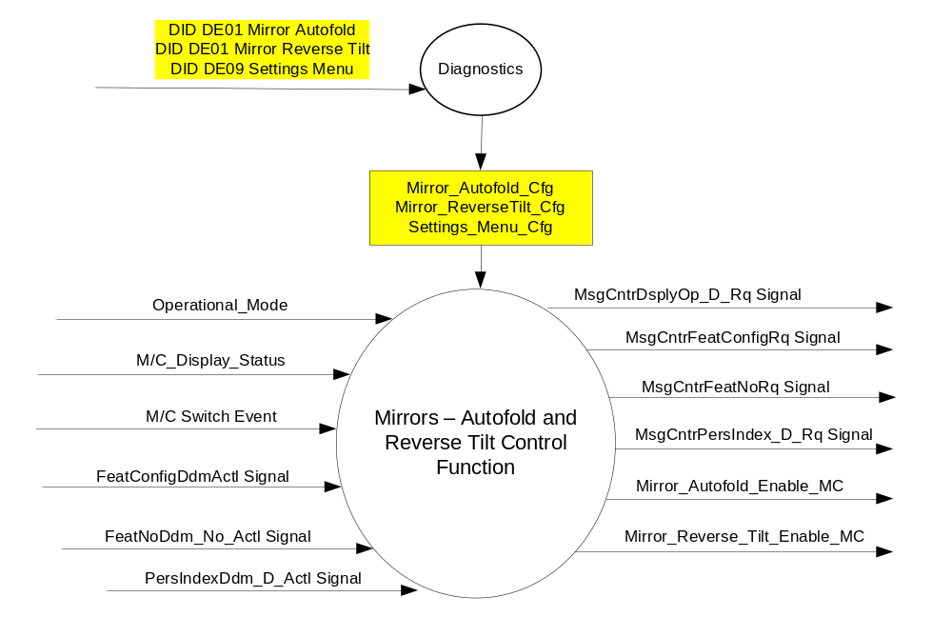

Inputs

- INTERNAL:
- Operational_Mode
- Mirror_Autofold_Cfg
- Mirror_ReverseTilt_Cfg
- Settings_Menu_Cfg
- M/C Switch Event
- M/C_Display_Status

- MUX signals on the CAN Bus from DDM

- FeatConfigDdmActl Signal
Signal Name | Size (bits) | Detail | Units | Res. | Offset | State Encoded | Min | Max
FeatConfigDdmActl | 16 | - | Undefined | 1 | 0 |  | 0  (0x0) | 65535  (0xFFFF)

- FeatNoDdm_No_Actl Signal
Signal Name | Size (bits) | Detail | Units | Res. | Offset | State Encoded | Min | Max
FeatNoDdm_No_Actl | 16 | - | Number | 1 | 0 |  | 0  (0x0) | 65535  (0xFFFF)

- PersIndexDdm_D_Actl Signal
Signal Name | Size  (bits) | Detail | Units | Res. | Offset | State Encoded | Min | Max
PersIndexDdm_D_Actl* | 3 |  | SED | 1 | 0 |  | 0  (0x0) | 7  (0x7)
 |  | PERS_1 |  |  |  | 0 (0x0)
 |  | PERS_2 |  |  |  | 1 (0x1)
 |  | PERS_3 |  |  |  | 2 (0x2)
 |  | PERS_4 |  |  |  | 3 (0x3)
 |  | Vehicle |  |  |  | 4 (0x4)
 |  | Unused |  |  |  | 5(0x5)
 |  | Unused |  |  |  | 6 (0x6)
 |  | Unused |  |  |  | 7 (0x7)
* Note that this signal may not be defined on a given program. If it is not defined, it is always set to 0x4 (Vehicle).

Outputs
- Mirror_Autofold_Enable_MC
- Mirror_Reverse_Tilt_Enable_MC
- MUX signals on the CAN Bus

- MsgCntrDsplyOp_D_Rq Signal
Signal Name | Size (bits) | Detail | Units | Res. | Offset | State Encoded | Min | Max
MsgCntrDsplyOp_D_Rq | 3 |  | SED | 1 | 0 |  | 0  (0x0) | 1  (0x7)
 |  | NULL |  |  |  | 0 (0x0)
 |  | QUERY |  |  |  | 1 (0x1)
 |  | SET |  |  |  | 2 (0x2)
 |  | UPLOAD |  |  |  | 3 (0x3)
 |  | RESTORE |  |  |  | 4 (0x4)
 |  | COPY |  |  |  | 5(0x5)
 |  | Not used |  |  |  | 6 (0x6)
 |  | Not Used |  |  |  | 7 (0x7)
.
- MsgCntrFeatConfigRq Signal
Signal Name | Size (bits) | Detail | Units | Res. | Offset | State Encoded | Min | Max
MsgCntrFeatConfigRq | 16 |  | Undefined | 1 | 0 |  | 0  (0x0) | 65535  (0xFFFF)

- MsgCntrFeatNoRq Signal
Signal Name | Size (bits) | Detail | Units | Res. | Offset | State Encoded | Min | Max
MsgCntrFeatNoRq | 16 |  | Number | 1 | 0 |  | 0  (0x0) | 65535  (0xFFFF)

- MsgCntrPersIndex_D_Rq
Signal Name | Size (bits) | Detail | Units | Res. | Offset | State Encoded | Min | Max
MsgCntrPersIndex_D_Rq* | 3 |  | SED | 1 | 0 |  | 0  (0x0) | 1  (0x7)
 |  | PERS_1 |  |  |  | 0 (0x0)
 |  | PERS_2 |  |  |  | 1 (0x1)
 |  | PERS_3 |  |  |  | 2 (0x2)
 |  | PERS_4 |  |  |  | 3 (0x3)
 |  | Vehicle |  |  |  | 4 (0x4)
 |  | Not Used |  |  |  | 5 (0x5)
 |  | Not Used |  |  |  | 6 (0x6)
 |  | Not Used |  |  |  | 7 (0x7)

* Note that this signal may not be defined on a given program. If it is not defined, it is always set to 0x4 (Vehicle).

Function/Performance

Operational Modes

Mode | Differentiating Vehicle Conditions
Sleep Mode | Mirrors Control Function Text Messages Disabled
Limited Mode | Mirrors Control Function Text Messages Disabled
Normal Mode | Mirrors Control Function Text Messages Enabled / Disabled
Crank Mode | Mirrors Control Function Text Messages Enabled / Disabled

Voltage Levels

Refer to the Cluster Features table located in the Operational Modes and Voltage Range Strategies Section in this SPSS.

Human-Machine Interface

Visual

Indicator Graphics / Display Format
For program specific display, refer to “<Program> Cluster Menu Structure.xls” and Program VAPS Model.
Example Graphics:

Mirrors | ▪ | Autofold |  | T: Autofold
Mirrors | ▪ | Autofold | ● | On
Mirrors | ▪ | Autofold | ❍ | Off
Mirrors | ▪ | Reverse Tilt |  | T: Reverse Tilt
Mirrors | ▪ | Reverse Tilt | ● | ON
Mirrors | ▪ | Reverse Tilt | ❍ | OFF

Or
Level 2
# Autofold Mirrors
# Reverse Tilt Mirrors

Indicator Color Coordinates

Reference section COLOR & ILLUMINATION REQUIREMENTS (GRAPHICS)

Indicator Characteristics

Refer to Message Center X Display_Y Button Interface Section, where X and Y are appropriate values in this document.

Audio

None

Switch Control Logic

Consumer access to the Mirror Control Configuration shall be as specified in the message center basic functionality display as specified in Message Center X Display_Y Button Interface Section, where X and Y are appropriate values in this document.

System Accuracy

Within a 100msec of receiving a message that results in a change of state the cluster will update the display to the proper status.

Operation: Performance and Functional

Subsystem Algorithm Flowchart / State Diagram

Figure 2 Autofold and Reverse Tilt Mirror Control Diagnostic Flowchart
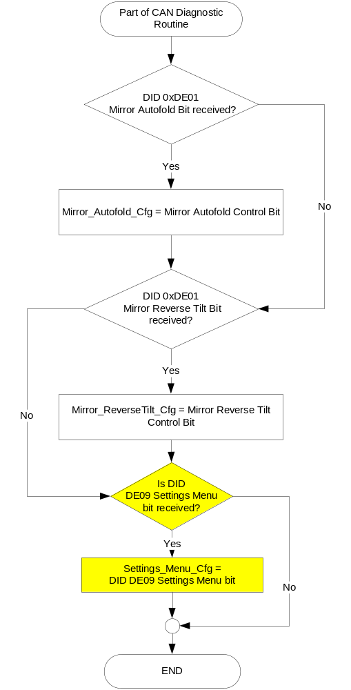

Figure 3: Autofold and Reverse Tilt Mirror Control Function Inputs request Flowchart

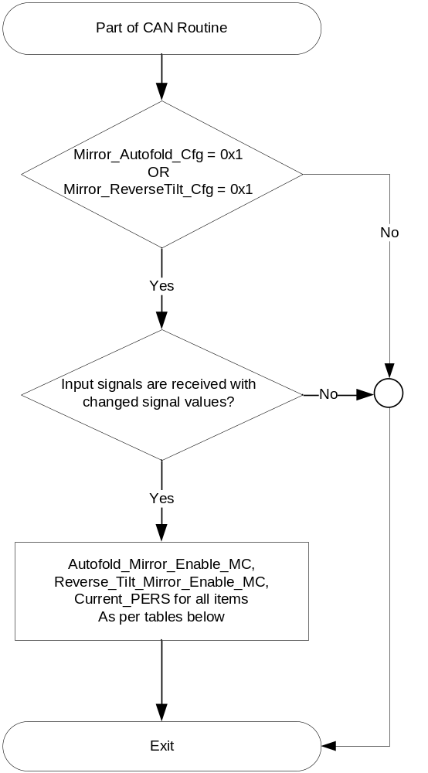

Figure 4: Autofold and Reverse Tilt Mirror Control Function output SET request Flowchart
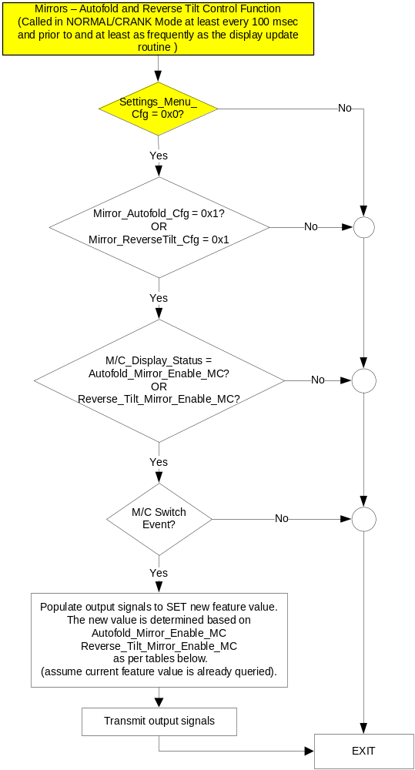

NOTE: In the Mirrors – Autofold and Reverse Tilt Control Function Flowchart, the definition of "M/C Switch Event" is defined in Message Center X Display_Y Button Interface Section, where X and Y are appropriate values in this document.

Operation Description (supports algorithm flowchart /state diagram)

- Mirror_Autofold_Enable_MC State Assignment
FeatNoDdm_No_Actl Signal | FeatConfigDdmActl  Signal | Autofold_Mirror_Enable_MC | Current_PERS ⁽³⁾
0x0702 ⁽¹⁾ | Disabled  (0x0000) | OFF (0x0) | 0x0 – 0x4
0x0702 ⁽¹⁾ | Enabled  (0x0001) | ON (0x1) | 0x0 – 0x4
0x0702 ⁽¹⁾ | Other ⁽²⁾ | Error  (0x2) | Last Known
Missing per Section 1.4.1 ⁽²⁾ |  | Error  (0x2) | Last Known
⁽¹⁾ Autofold Mirror Enable Feature Number. Reference is Feat Num table in “Vehicle Personalization FS”
⁽²⁾ Message Response is Faulted
⁽³⁾ Equal to the received “PersIndex<--->” signal value . When faulted Keep last known value.

- Message Center Display and MC Autofold Mirror Enable Request Messages

based upon Autofold_Mirror_Enable_MC
Autofold_Mirror_Enable_MC | Display Menu | M/C Switch Selection Event | MsgCntrDsplyOp_D_Rq Signal | MsgCntrFeatNoRq Signal | MsgCntrFeatConfigRq  Signal | MsgCntrPersIndex_D_Rq Signal
Disabled  (0x0) |  | Up/Down + OK (Select ON) | SET (0x2) | 0x0702 | 0x0001 (if ON is Selected) | Current_PERS
Enabled  (0x1) |  | Up/Down + OK (Select OFF) | SET (0x2) | 0x0702 | 0x0000 (if OFF is Selected) | Current_PERS
Error  (0x2) |  | Up/Down + OK (Select ON or OFF ) | SET (0x2) | 0x0702 | 0x0000 (if OFF is Selected)  0x0001 (if ON is Selected) | Current_PERS
Note: Mirror_Autofold_Cfg must be enabled (0x1) to display this menu.

- Reverse_Tilt_Mirror_Enable_MC State Assignment
FeatNoDdm_No_Actl Signal | FeatConfigDdmActl  Signal | Autofold_Mirror_Enable_MC | Current_PERS ⁽³⁾
0x0703 ⁽¹⁾ | Disabled  (0x0000) | OFF (0x0) | 0x0 – 0x4
0x0703 ⁽¹⁾ | Enabled  (0x0001) | ON (0x1) | 0x0 – 0x4
0x0703 ⁽¹⁾ | Other ⁽²⁾ | Error  (0x2) | Last Known
Missing per Section 1.4.1 ⁽²⁾ |  | Error  (0x2) | Last Known
⁽¹⁾ Mirror Reverse Tilt Feature Number. Reference is Feat Num table in “Vehicle Personalization FS”
⁽²⁾ Message Response is Faulted
⁽³⁾ Equal to the received “PersIndex<--->” signal value, always Vehicle (0x4) only. When faulted Keep last known value.

- Message Center Display and MC Reverse Tilt Mirror Enable Request Messages

based upon Reverse_Mirror_Tilt_Enable_MC
Reverse_Tilt_Mirror_Enable_MC | Display Menu | M/C Switch Selection Event | MsgCntrDsplyOp_D_Rq Signal | MsgCntrFeatNoRq Signal | MsgCntrFeatConfigRq  Signal | MsgCntrPersIndex_D_Rq Signal
Disabled  (0x0) |  | Up/Down + OK (Select ON) | SET (0x2) | 0x0703 | 0x0001 (if ON is Selected) | Current_PERS
Enabled  (0x1) |  | Up/Down + OK (Select OFF) | SET (0x2) | 0x0703 | 0x0000 (if OFF is Selected) | Current_PERS
Error  (0x2) |  | Up/Down + OK (Select ON or OFF ) | SET (0x2) | 0x0703 | 0x0000 (if OFF is Selected)  0x0001 (if ON is Selected) | Current_PERS
Note: Mirror_ReverseTilt_Cfg must be enabled (0x1) to display this menu.

Function Safety Classification (EMC)

Class B

Memory Storage

Parameter Name | Description | Value at  Battery Connect | Value at  Module Wake-up
Mirror_Autofold_Enable_MC  Mirror_Reverse_Tilt_Enable_MC | Outputs displayed in the M/C | Disabled | Do Not Init
MsgCntrDsplyOp_D_Rq Signal | Output Signal to indicate Request Type. | NULL (0x0) | Do Not Init
MsgCntrFeatNoRq Signal | Output Signal to indicate Feature Number. | (0x0000) | Do Not Init
MsgCntrFeatConfigRq Signal | Output Signal to Specify the desired feature Value. | (0x0000) | Do Not Init
MsgCntrPersIndex_D_Rq Signal | Output Signal to indicate which personality profile is being accessed. | Vehicle (0x4) | Do Not Init
FeatNoDdm_No_Actl Signal | Input signal sent from DDM to indicate Feature Number. | (0x0000) | Do Not Init
FeatConfigDdmActl Signal | Input signal sent from DDM to indicate current value of the feature setting for the feature that is being set or queried. | (0x0000) | Do Not Init
PersIndexDdm_D_Actl | Input Signal to indicate which personality profile is being accessed. | Vehicle (0x4) | Do Not Init
Mirror_Autofold_Cfg | Configures cluster for Autofold mirrors. Set to Disabled at Cluster Supplier Manufacturing Plant. | Use Stored Value | Use Stored Value
Mirror_ReverseTilt_Cfg | Configures cluster for Reveres Tilt mirrors. Set to Disabled at Cluster Supplier Manufacturing Plant. | Use Stored Value | Use Stored Value
Settings_Menu_Cfg | Configures cluster to display items in the Settings menu (Set to “cluster” at cluster supplier manufacturer plant) | Use Stored Value | Use Stored Value
M/C_Display_Status | State Indicator to identify which text is currently being displayed on Message Center display. See * | See * below | See * below
M/C Switch Event | Event that is indicated as per the switch interface for the Message Center. See * | See * below | See * below
Operational_Mode | 4 state indicator for cluster operational mode | Limited | Limited, Normal or Crank

* Refer to Message Center X Display Y Button Interface Section, where X and Y are appropriate values in this document.

Reconfigurable Telltale

Not Applicable

Prove Out

Not applicable

Message Center Msg

Refer to program specific menu structure and menu navigation for message IDs.

Error Handling

Missing Message Strategy

The signals will be declared missing as per the Diagnostics section of this SPSS.

DTCs states and history will be determined as per the Diagnostics section of this SPSS.

If Mirror_Autofold_Cfg = Disabled, the cluster shall never log a missing message DTC due to this feature.

Diagnostics

Self Test

None

Engineering Test Mode

Reference section “Dealer / Engineering Test Mode (ETM)”

Part II Performance

Supported Diagnostic Trouble Codes (DTCs)
DTC | Description
C19900 | Lost communication with DDM (Door Control Module A)

DID DExx:
Block  Num | Block Description | Byte(s) | Bits | State: Description | "0" | "1" | Default | Comments/  Information
PACKETED BLOCKS
$01 | Option Content (B&A) | * | * | Mirrors Autofold | Disabled | Enabled | Disabled | Parameter allows the "Mirrors - Autofold - On/Off" menu to be displayed in the cluster. The menu can be over-ridden by the Settings Menu config.  This option in the DDM is typically available on Lincoln or FoE/China variants only.  Enable if DDM supports feature and per program direction.
$01 | Option Content (B&A) | * | * | Mirrors Reverse Tilt | Disabled | Enabled | Disabled | Parameter allows the "Mirrors - Reverse Tilt - On/Off" menu to be displayed in the cluster. The menu can be over-ridden by the Settings Menu config.  This option in the DDM is typically available on Lincoln or FoE/China variants only  Enable if DDM supports. feature and per program direction.
$09 | Option Content (B&A) | * | * | Settings Menu | Cluster | Center Stack | Cluster | This parameter allows the Settings menu to be displayed in the cluster when 0x0. When 0x1, the expectation is that settings are displayed in the Centerstack. For this feature (when 0x1), the cluster will remove almost all items from settings menu. (Cluster display choices remain). Note this is a global config, each feature still has its own config for presence on vehicle.
*Byte and bit location to be identified in Part II Specification for this cluster

Reference Specification

None.

Revision History
SPSS Module Revision History
Revision Level | Name | Change Description | Date
1.0 | V. Patel | Initial release. | 12/14/2010
1.1 | S. Watkins | Minor cleanup.  Section 1.2.3 – Added note below Table 1.5 “always set to Vehicle(0x4).”  Section 1.3.5.2, table 1.8, added text “”always Vehicle only (0x4)” to footnote | 5/11/2011
1.2 | S. Watkins | Remove the changes of version 1.1, since Enhanced Memory (Personalization) is back for some programs. Added in signal PersIndexDdm_D_Actl. Also commented out the Reverse Tilt Control, since no BCM to date has supported Feature # 0x0703. | 10/9/2012
1.3 | S. Watkins | It was found that a supplier still logged the missing message DTC, even when Mirror_Autofold is configured off. Thus, added requirement to NOT log a DTC unless configured on.  - Section 1.4.1 – Added “If Mirror_Autofold_Cfg = Disabled, the cluster shall never log a missing message DTC due to this feature” | 7/29/2014
1.4 | S. Watkins | Per John Ricks and Dana Butala in the BCM team, the DCU now supports Feature #0x703. Thus, I am undoing the strikethrough’s from version 1.2. This is planned starting in MY18 U55x. | 1/30/2015
1.5 | R. Chalanti | Removed a statement in Functional description as part of clean up | 8/4/2015
2.0 | S. Watkins | Starting in MY2019 with U625/U611 the Settings are migrating from the cluster to Centerstack. This STSS update is to support this effort. A configuration is added to ensure backward compatiblity.  Changes shown in yellow:  - Section 1.1 – Updated description to mention Center Stack  - Section 1.2.1, Figure 1 – Added DE09 Settings Menu  - Section 1.2.2 – Added Settings_Menu_Cfg  - Section 1.3.5.1, Figure 2 – Added DE09 Settings Menu  - Section 1.3.5.1, Figure 4 – Added decision box for Settings_Menu_Cfg and also added “Crank” to first box (defect fix unrelated to other changes).  - Section 1.3.5.4 – Added Settings_Menu_Cfg  - Section 1.5.3 – Added Settings Menu to DE09 | 1/14/2017

